PHYSICAL CONTEXT MODULE

Goals

This module is intended to update participants with the emerging concepts and skills on physical context management, with a basic understanding and knowledge of training space set up for exercises and activities. Setting up an efficient training space, ensuring the comfort of participants, understanding how to manage small and big groups, how to set up a room for table top exercises and how to debrief and ask for feedback are essential facets of physical context aspects and keys to a successful learning experience.

Learning Objectives

On completion of this session, participants will be able to:

- Use space management tips when facilitating learning activities, in particular table top exercises;
- Set up an ergonomic training space according to the type of training and audience;
- Understand the principles of group dynamics and how to manage a group to help them learning;
- Apply the basic concepts of verbal and non-verbal communication to improve the effectiveness of the activities;
- Use proxemics to enhance the effectiveness of the activities;
- Become familiar with debriefing models and understand how to set up training space to facilitate the debriefing process.

Core Content

- Components of physical context for training

It has been demonstrated that the environment affects the learning outcome; creating a safe environment within which delivering activities is essential to improve the effectiveness of the training course delivered. In this context, safety does not refer to physical safety (that must be guaranteed anyway!) but to the protection from psychological or emotional harm. A safe environment is a condition that allows students to be comfortable in expressing personal opinions, sharing their knowledge, taking risks and explore their behaviors¹.

Safety in a learning environment goes beyond physical well-being. In order to maintain a safe learning environment, learners must feel supported, welcomed, and respected.

Although the approach used by the trainers and participants’ behaviour has a pivotal role in making an environment safe, the physical setting affects the outcome as well.

The right illumination, acoustics, temperature and room size have been highlighted as important characteristics in creating a learning-oriented environment; also a seating arrangement that allows to see everyone contributes to a safe context¹. The configuration of the space affects the interaction between students and the attention level².

Short checklist to ensure a good physical environment³:
- Is the room of the right size?
- Is the temperature comfortable?
- Are there any distractions (noise, visual distractions inside or outside)?
- Is the seating adequate, and how should it be arranged?
- Does the audio-visual equipment work?

Here below are some tips to create a great training environment:
- U-shaped seating for open training presentations
- Audio equipment installed for videos and replays
- Ceiling mounted projector for uninterrupted delivery
- Well illuminated area with natural light for open comfort
- Temperature controlled for perfect conditions
- Venue assistance close at hand for uninterrupted set-up
- Internet connection properly working
- Separate break area for change of setting
- Washroom close at hand for convenience
- Health and safety in place for emergency

- Room Set Up
A training space is more than just a room, it is a place where new skills and ideas are born. Choosing a training venue that is designed for training demonstrates commitment to learners, to the project itself and to the learning outcomes.

An effective learning space is designed following pedagogic theories, and should be configured to promote a collaborative and active approach⁴. The seating layout influences the interaction of the students between them and with the teacher; some layouts foster the students to be on task, others foster collaboration⁵. The knowledge of the main classroom layouts is fundamental to choose the best suited one for the specific activity.

The most used set ups are⁴:
- Frontal layout
- Teaching in the round layout
- Student clusters layout
- Cabaret layout
- Decentralised layout

The table below summarizes the main aspects of each layout:
- Teacher-focused layout. A teacher-focused layout is suitable for frontal lectures, although it affects the interaction between students.
- Academic challenge. The promotion of multiple means of teaching is one of the 21st century challenges, to improve the learning process.
- Learning with peers. Especially for teamwork-based activities, an environment that promotes the discussion with peers is crucial.
- Interaction with the teacher. The interaction with the teacher promotes the questions from the students and contributes in building a safe environment.

 | Teacher-focused | Academic challenge | Learning with peers | Interaction with teacher
Frontal classroom | + + | - - | - - | - -
Teaching in the round | + | - | - | +
Students clusters | + / - | + | + + | +
Cabaret | - - | + + | + + | + +

Frontal Classroom

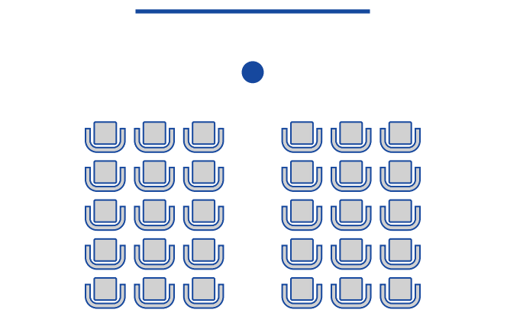

Teaching in the round

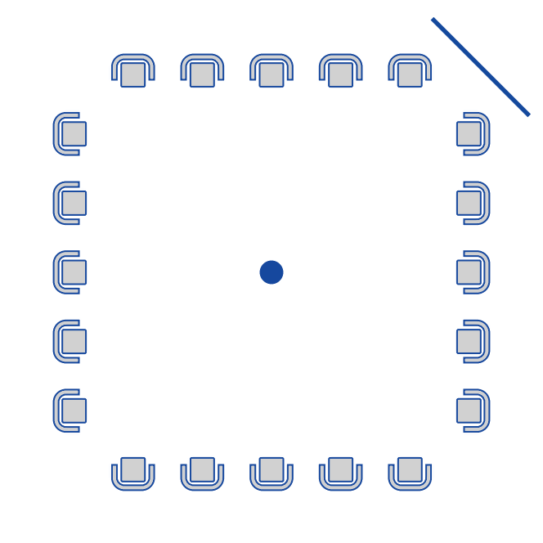

Students clusters

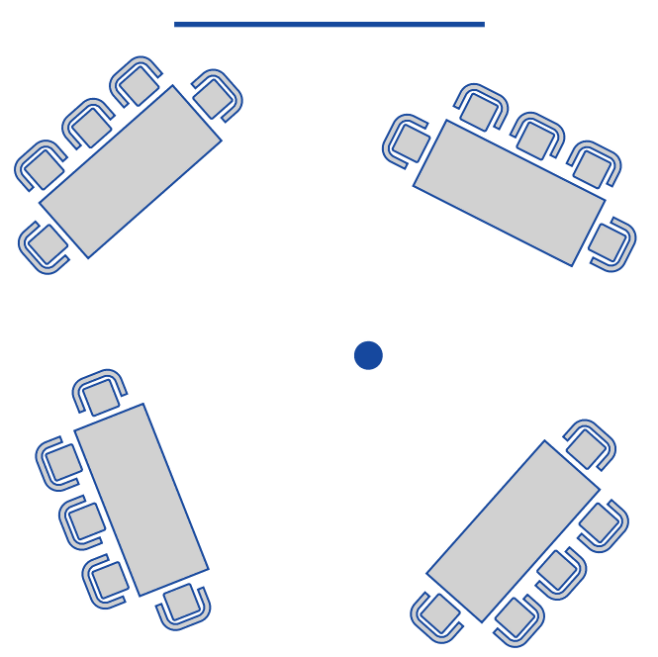

Cabaret

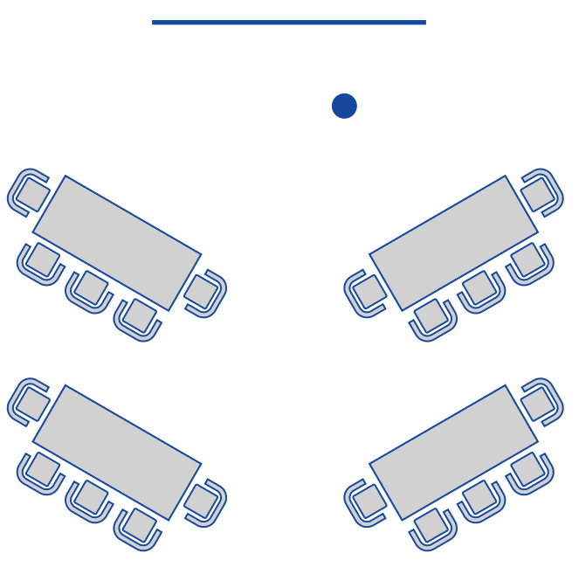

- Non-verbal communication

“The most important thing in communication is hearing what isn’t said.”
–Drucker.

Instead of written or oral words, non-verbal communication relies on various non-verbal cues like physical movements, tasks, colours, signs, symbols, signals charts etc. to express feelings, attitudes or information. Although no word is used in non-verbal communication, it can effectively communicate many human feelings more accurately than verbal methods of communication.

Types of Nonverbal Communication

- Eye contact
- Facial expressions
- Gestures
- Posture and body orientation
- Body language
- Space and distance
- Proximity
- Para-linguistic
- Humor
- Touch
- Silence
- Personal Appearance
- Symbols
- Visual Communication

Many of the above-mentioned traits fall under the sphere of physical context.
Space and distance are significant non-verbal tools in the case of organizational communication. A spacious and well-decorated room indicates a person’s position in the organization hierarchy and external people get a message about his importance and authority only by visiting his room. So it is for training: a properly set and well decorated space conveys the idea of how well the training was prepared.

Distance is another communication tool which expresses the degree of intimacy and individual acceptance.

- Proxemics

The interpersonal distance, or interpersonal space, is an human characteristic linking social interactions with the physical environment⁶. Informally called “breathing space”, the distance unknowingly maintained during interpersonal interaction is the study subject of a specific discipline, the proxemics⁷. This space helps to control the sensory exposure depending on the social situation⁷. When something or someone invades the interpersonal space, the person may feel uncomfortable and shows a physiological reaction⁸.

Classically⁷, the interpersonal space is classified in four types, reflecting different types of relationship:
- Public distance (>210cm) with minimal eye contact and louder voice
- Social distance (122-210cm) with only visual and auditory stimuli
- Personal distance (46-122cm) with increased vocalization and vision no longer blurred
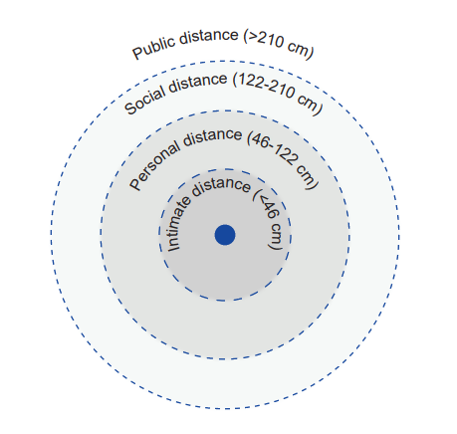
- Intimate distance (0-46cm) with blurred vision and increased perception of heat and olfactory stimuli.

Although this classification can be applied to the majority of the societies, the ranges of distances vary according to the cultural norms and the specific environment⁹. The invasion of the intimate distance may results in a feeling of discomfort¹⁰. On the other hand, a great distance between the teacher and the students may interfere with students’ participation¹¹.

In general, the interpersonal distance should be greater in formal meeting where the communication is mainly unidirectional (e.g. frontal lecture); on the contrary, during informal meeting with interactive exercises the interpersonal distance could be reduced.

A basic knowledge of proxemics is essential to approach correctly a learning environment; the trainer should choose the best interpersonal distance assessing:
- The type of session (formal/unformal)
- The environmental setting
- The learning methodologies implemented during the session (frontal lectures, teamworking, open discussion)

- Principles of group dynamics

Group dynamics or group process describes the way in which any group of humans interacts and develops as a group, and the relationship between the group and the individuals within it.
Understanding group dynamics principles in training are essential for the facilitator to create a positive atmosphere and openness to learning. Seeing how group members interact and what might cause friction in a group, can help trainers to improve group performance, communication, and cohesiveness.

There are 7 parts of group dynamics that can determine patterns of interactions between the members of the group:

- Size (number of participants)
- Norms (or rules – from work or established by the facilitator)
- Cohesiveness (e.g. if they worked together before)
- Roles (roles from work environment are brought into the training room
- Status (is it a formal or informal group?)
- Objectives (are all members aware of the objectives of the training and striving for them?)
- Space (is physical space adequate to the training and exercises are customized according to the space available?)

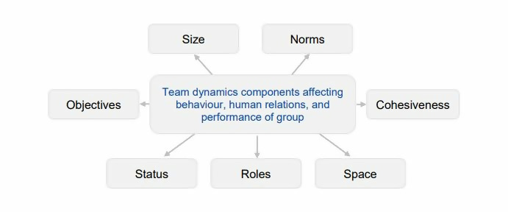

- Group management methods recommended based on group size and space

Depending on the experience of the facilitator and the time allocated for an activity/exercise, a small group could have up to 12-18 participants.

We define a big group when the number of participants is more than 18. In general, any group bigger than 18 or some say, 24 participants, should be approached differently. The facilitator should use different methods and expect less interaction or quality of interaction between the participants, depending on the activities/exercises and learning objectives.

The following are the methods we recommend based on group size:

Small group | Big group
Learning exercises for the entire group | Learning exercises are recommended in pairs, in groups of 3, groups of 5 or maximum 8.
Presentations delivered using the flipchart and colorful paper, invite participants to take notes and contribute with ideas during the presentation. | Presentations delivered using the video projector so everyone can see. Use interactive apps, sending pictures or files to participants’ mobile phones. Contributing with ideas is sparse as you might ran out of time.
Content delivery: splitting the time in several blocks of content followed by Q&A and activities. | Content delivery: splitting the time in 3 standard blocks:  - Use EAT method (experience, awareness/debrief, theory) and Q&A at the end  - Use TEA method (theory, experience, awareness/debrief) and Q&A at the end  The Q&A is recommended to be scheduled at the end of the session because there is a big chance that a big group will have many questions (consider delays)
Collecting ideas/inputs: ideas be expressed verbally, each participant stating their opinion, while the trainer/facilitators writes them down on a flipchart. | Collecting ideas/inputs: it is advisable to collect ideas and inputs on post-its and collect them on a wall at the exit. For big groups, it should be done using technology: use an app where people can vote from their mobile. You can then pick a post-it / most voted ideas and share them with the room. This way some ideas will be known, but most of them will not.
Debriefing activity: in a small group, the trainer can focus on the experience of each participant and help them reflect on their learning outcome. | Debriefing an activity: in a big group, the facilitator could display some inputs or thoughts to reflect on in a PPT slide and ask participants to answer on their own.  If there is an activity where the big group has been split in teams of 5-8 member, the facilitator can display the questions on a PPT or ask a spokesperson from each group to sum up the main points discussed.

- Considerations on Physical Space for tabletop exercises

Tabletop exercises are discussion-based sessions where team members meet in an informal, classroom setting to discuss their roles during an emergency and their responses to a particular emergency situation.

Tabletop exercises have different traits compared to other types of activities.

- Participants are usually sitting around a table or in a defined space and all materials about the case study are provided in advance.

- The workspace should be properly equipped with flipcharts, pens and chairs. If possible, posters, infographics, pictures related to the topic discussed should be hang on walls to facilitate visualization.

- Interactions among participants are as important as the exercise itself, sometimes more important than the final outcome. Set up a space that facilitates dialogues.

For bigger groups, a good example of technique to facilitate a table top exercises is the Round Robin. The Round Robin is for rapid and intense engagement with subject matter experts. It is similar to a World Café, but is guided by experts. Participants address the subject matter in a series of rotations within small groups.

It recommended to set up separate working spaces that are close enough together for quick transitions of people, yet far enough apart not to create a lot of noise interference (similar to word Café).

Each space should be equipped with a writing wall or flipcharts, writing utensils and a semi-circle of chairs. Divide the writing wall into columns for each discussed topic under consideration or set up one flip-chart for each topic/theme. If using flipcharts, write key points on a flashcard so that it can be moved to new pages as they are filled up and turned over.

- Space is also a component of debriefing

When it comes to training and facilitation, three different dimensions can be distinguished: space, people and process and they all form the so-called Facilitation Anchor Grid.
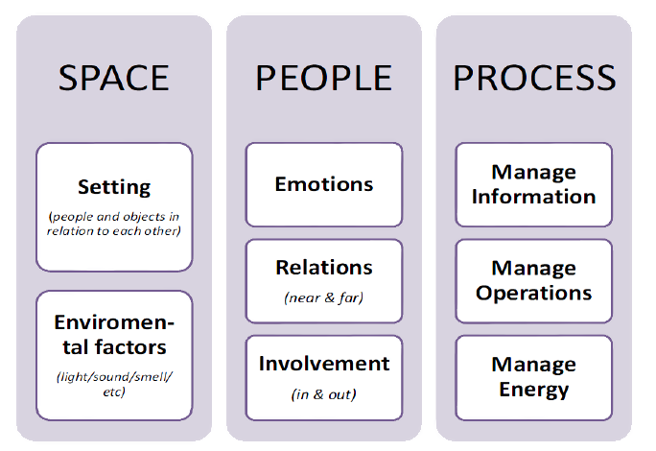

These 3 dimensions should be taken into consideration not only for design and delivery a training and for the debriefing part.

We can conclude by saying that today’s learners seek a learning environment that is not as obsolete as traditional classrooms but that is specifically engineered to support thinking. This means that just the simple room set up or table disposition play a role in learning.
The audience receiving training prefer a learning environment that pushes their learning capacity with altering strategies and exercises, instead than frontal classes with a projected Power Point presentation. Learners want to be a part of an impactful learning setting that provides a sense of achievement while they can be adaptive and interactive with fellow learners as well as instructors. In brief, they want to be active and engaged players throughout the learning course and they want to learn by doing.

References

Types of exercises: https://www.ready.gov/business/testing/exercises

Types of feedback: https://www.talkdesk.com/blog/types-and-sources-of-feedback-in-the-workplace/

The Kirkpatrick impact/feedback model: https://www.webanywhere.co.uk/enterprise/how-to-evaluate-your-learning-programme-the-kirkpatrick-model/

Additional Resources

Advantages and disadvantages of table top exercises: https://uwpd.wisc.edu/content/uploads/2014/01/What_is_a_tabletop_exercise.pdf

Key benefits in using table top exercises: https://www.preparedex.com/5-benefits-conducting-tabletop-exercises/

Questions

QUESTION 1: Why is group dynamics relevant for a facilitator?

QUESTION 2: Which of the following delivery methods are the most suitable for small groups?
- Using a PPT so the audience can look at the screen and interact with the facilitator only if needed
- Using games and props for teams of 5 people
- Using time wisely and letting each participant share their opinion in front of the whole room

Answer:
Option c) is the most suitable because interaction is the biggest added-value you can bring to a learning experience to a small group.

QUESTION 3: When is it suitable to use table top exercises?
- For team building when people need to meet and have fun
- To reproduce scenarios
- To address and tackle personal issues a participant might have with one or more of his colleagues
Answer:
Option b is correct.

QUESTION 4. What’s proxemics and how many “distance types” has been described?

QUESTION 5. What is the physical context of communication?
- How physically close the people who are communicating are to each other
- The use of nonverbal communication- things like hand gestures and body language
- The actual setting where communication is happening
- The expectations of each person
Answer:
Option a,b,c.

